STATE OF CALIFORNIA Gavin Newsom, Governor
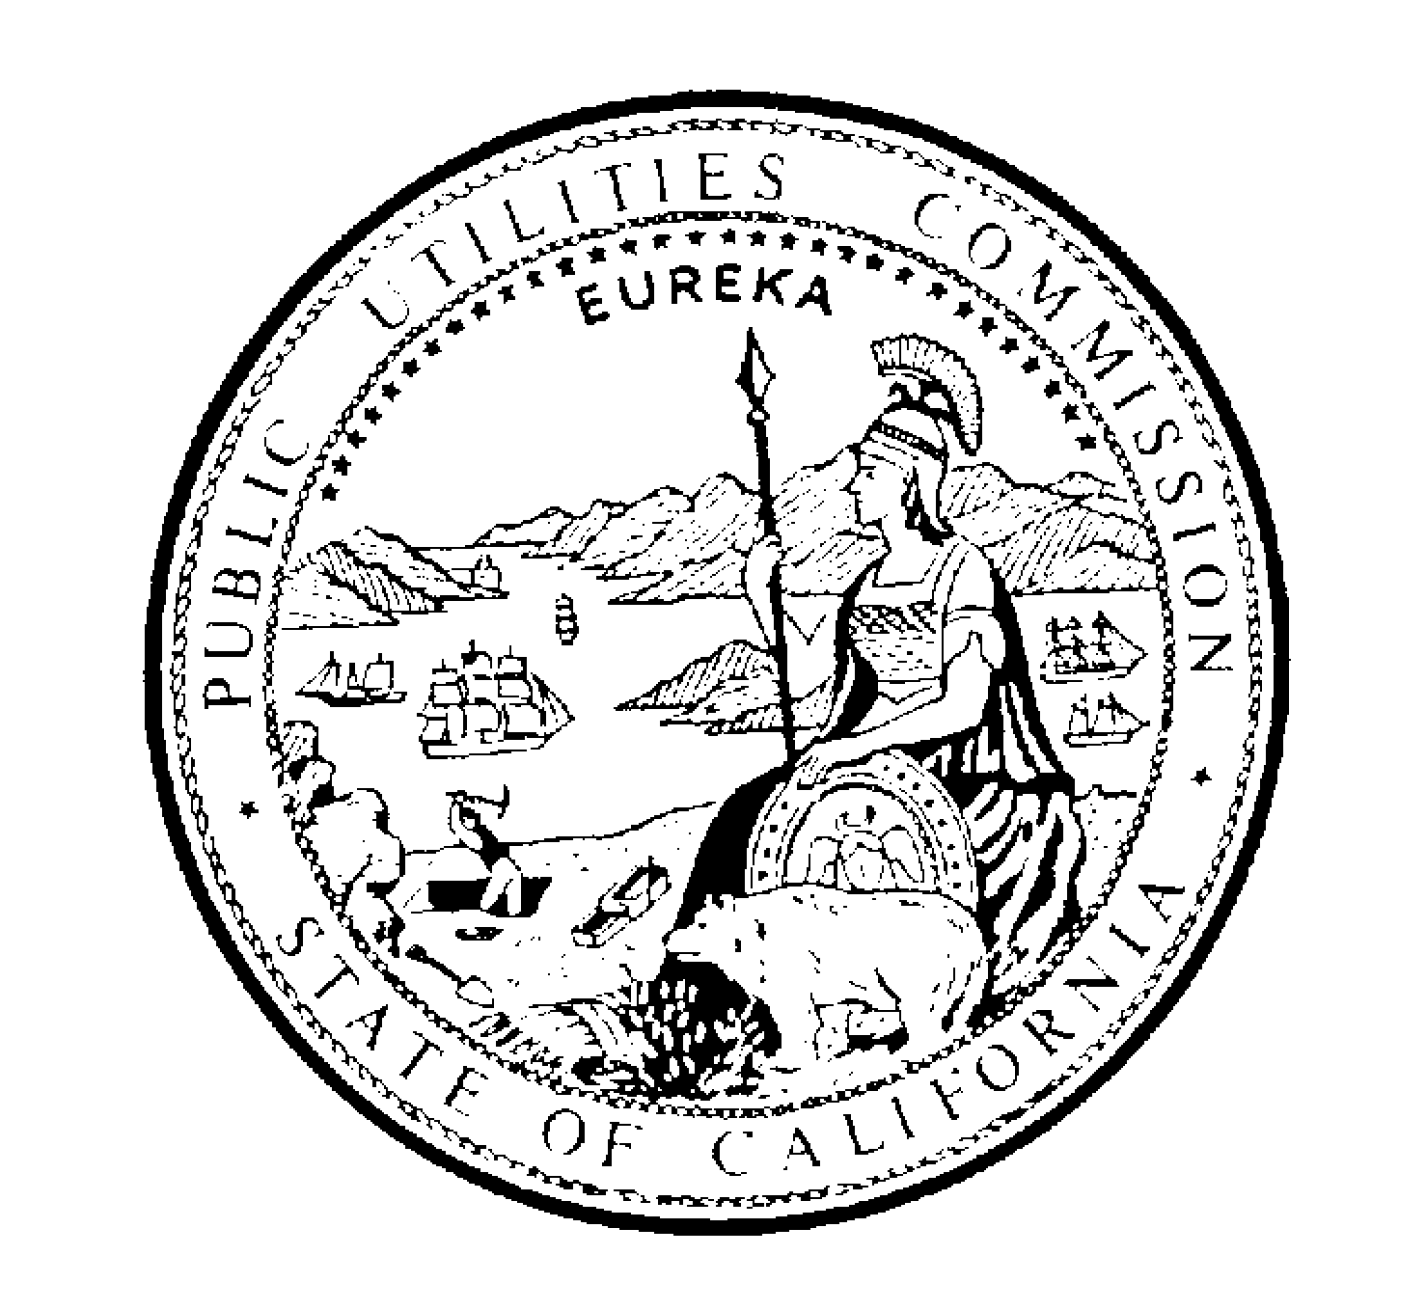PUBLIC UTILITIES COMMISSION
505 VAN NESS AVENUE
SAN FRANCISCO, CA 94102-3298

March 10, 2021

Mr. John Gutierrez
Director Government Affairs
Comcast
3055 Comcast Place
Livermore, CA 94551

Dear Mr. Gutierrez:

The Commission has determined that Comcast’s application for its 46th amendment, which was submitted on February 16, 2021 is not complete. Until Comcast makes the necessary revisions to the application, as described below, the 30-day application clock will be paused.

For Comcast’s application for its 46th amendment to be considered complete, we need Comcast to revise the application so it reflects the answer “yes” to question nine on the application. Question nine asks: “Does the Applicant alone or together with its Affiliates have more than 1,000,000 telephone customers in California?”

The Video Franchising team has received clear guidance from the CPUC Legal Division that VoIP service providers fall within the definition of “Telephone Corporation” under Section 234, and their facilities fall within the definition of “Telephone Line” pursuant to Section 233. Under California law, the means by which service is provided, whether it be traditional landline, wireless technology, or IP-enabled, does not affect whether the provider meets the definition of a public utility telephone corporation. Attached are D.20-09-012, and D.21-02-019 (see pages 8-11), which describe this.

In addition, as Comcast has more than 1 million telephone customers, Comcast must meet the requirements for providing free service to community centers, as described in DIVCA. That requirement does not need to be met before we process the 46th amendment. We are happy to discuss the requirement for providing free service to community centers with you.

Best Regards,

Michael Pierce
Sr. Analyst
Video Franchising Team
California Public Utilities Commission

cc: Michael Morris, Pik Tang Dion Good

